**SUPPLEMENTARY FIGURE S10: Comprehensive maternal health dashboard**

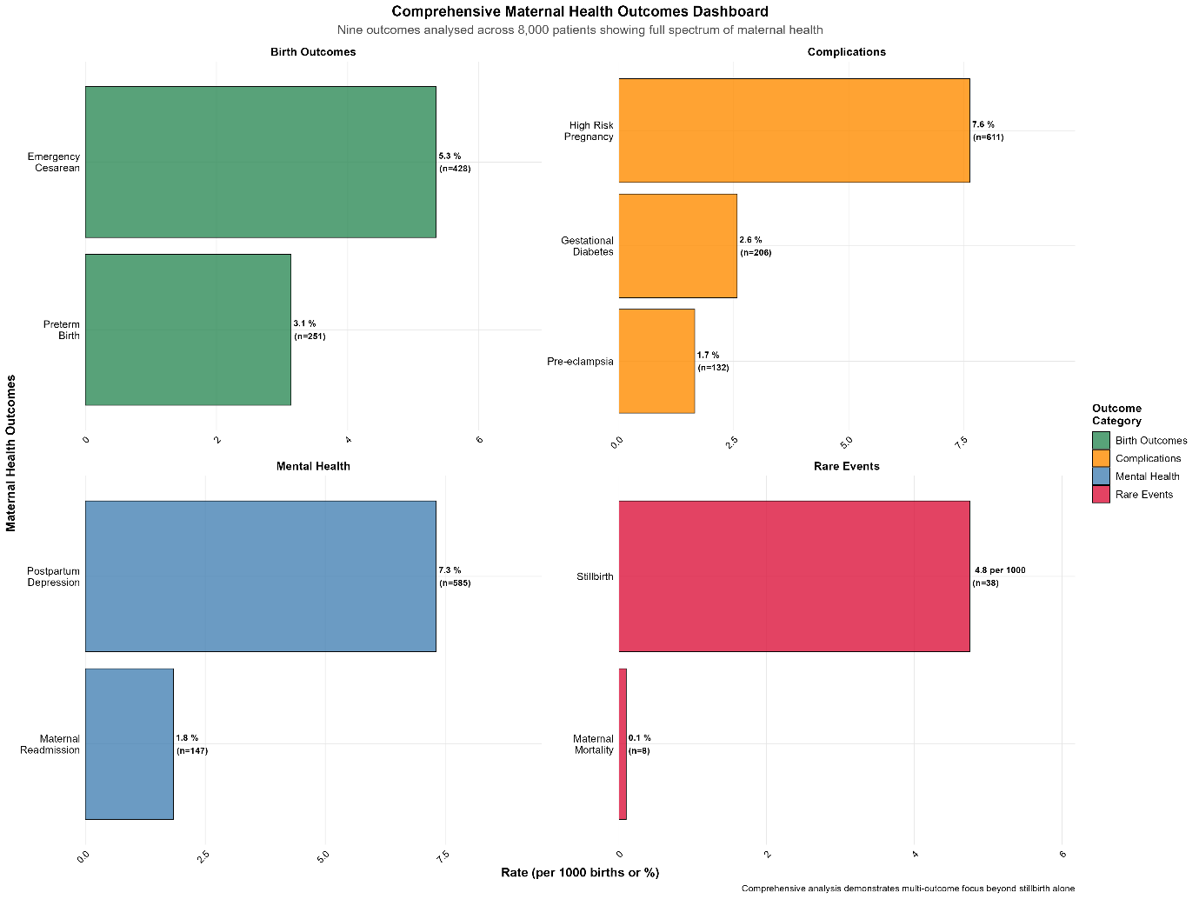

Comprehensive maternal health outcomes dashboard showing prevalence across nine outcomes categorised as birth outcomes, complications, mental health, and rare events. Analysis of 8,000 patients demonstrates multi-outcome focus addressing full spectrum of maternal health beyond stillbirth alone. High-risk pregnancy (76%) and postpartum depression (7.3%) represent highest prevalence conditions.